AUSSIE LANDSCAPES TOUR

by Eco Safaris Queensland (ESQ)

7 Day Tour from Brisbane or Gold Coast

INTRODUCTION
Explore a variety of stunning, uniquely Aussie landscapes from standing on the crater’s edge of an ancient volcano to a lighthouse overlooking some of the world’s most beautiful beaches. Feel a million miles away and discover the region’s ‘hidden gems’. Pass through a variety of Australian forests including three UNESCO World Heritage listed rainforests. There are stunning lookouts every single day over a great variety of landscapes. This tour focuses on the natural beauty that makes Australia unique.

ACCOMMODATION
Options from mid-range to luxury. Luxury options suggested below.

FITNESS LEVEL
From very light to strenuous; this depends on guest’s preferences. Guests can still see the large majority of sights with a light level of fitness. However, numerous beautiful walks are available for the more active.
This itinerary is quite full, but if guests prefer we can arrange plenty of time to relax amongst the natural settings.

PERSONALISED ITINERARY
Numerous options are available from horse riding on a deserted stunning beach (extra cost) to superb wine tasting from a 5-star winery. This tour focuses on the natural beauty of the region. Tours can, however, include visits to Brisbane City, Gold Coast and wildlife parks where guests can hand-feed kangaroos and pat koalas.

TOUR LENGTH
Tour length can be adjusted to any time frame. Discuss with ESQ to take days out or add days. If guests arrive into Brisbane at any time through the day, we can pick the guests up at the airport or other location and start the tour straight away. We will adjust the price accordingly if touring on that day tour is less than a full day. We can also drop off at any time on the last day.

TOUR INCLUSIONS
- Luxury Land Rover Discovery or similar vehicle
- Great lunch every day (you’ll never go hungry)
- Great afternoon or morning tea every day
- Private and fully personalised itinerary
- Fun, local, knowledgeable guide
- Unlimited fruit, snacks, drinks & chocolate.

DAY 1 – UNESCO SPRINGBROOK RAINFORESTS AND WATERFALLS
- Pick up anywhere in the region e.g. Brisbane or Gold Coast.
- Purlingbrook Falls – 106m (350 feet) high falls flow into a gorge filled with palms, fern and lilies.
- As we drive, learn how 23 million years of history made the incredibly biodiverse Tweed Shield Volcano and Springbrook Mountain.
- Canyon Lookout – Stunning views over the Gold Coast coastline.
- Twin Falls walk – Amazing walk descending deep into the forest past waterfalls, streams, rock pools, a small caves and behind Twin Falls. Enjoy a snack or ‘gourmet packed lunch’ deep in the rainforest, by the rock pool at the base of these majestic falls.
- Other lunch option is at a charming mountain café.
- Best of All Lookout - Wander past the majestic, 2000 year-old, Antarctic Beech tree to the crater’s edge with incredible views over the Green Cauldron, Mt Warning and down to Byron Bay.
- Natural Bridge – an amazing rock and waterfall formation. First witness the waterfall plunging into a hole in the ground from above before getting up close by walking inside the cave!
- Afternoon tea of the world’s best carrot cake with tea or coffee in a charming little village.
- Accommodation Suggestion: The Byron at Byron Resort & Spa

DAY 2 – BYRON BAY & SURROUNDS
- Cape Byron Lighthouse – Described by Neil Oliver (‘Coast’) as the most spectacular coastline views he has ever seen.
- Morning tea at ‘The Farm’ – Northern NSW’s organic culture in a gorgeous country setting.
- Guided walk around the headland to Australia’s most easterly point. Over the Pacific, keep a look out for kangaroos, dolphins, sting rays, sharks, whales (May to November) and turtles.
- Walk along the stunning, near deserted Tallows Beach.
- Relax in the funky, arty, eclectic town of Byron Bay with cafes, shops and local arts.
- Plenty of time to just chill out on Byron’s world famous beaches.
- For the more active, drive into the lush, green hinterland to a pretty rainforest walk.
- Gourmet lunch at charming, relaxed country restaurant.
- Chic country town of Bangalow.
- White’s Beach – For the active, walk down the unmarked track to a ‘local secret’ which has recently been declared Australia’s most beautiful beach.
- Accommodation Suggestion: The Byron at Byron Resort & Spa
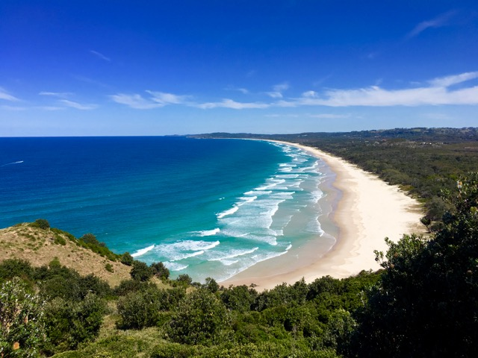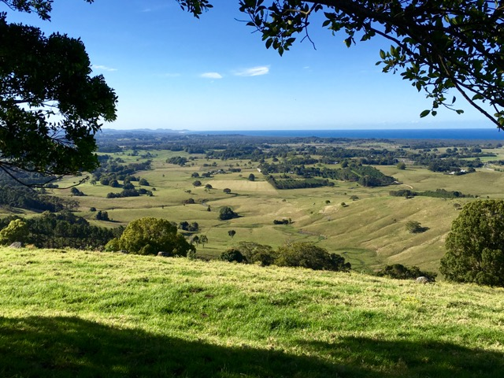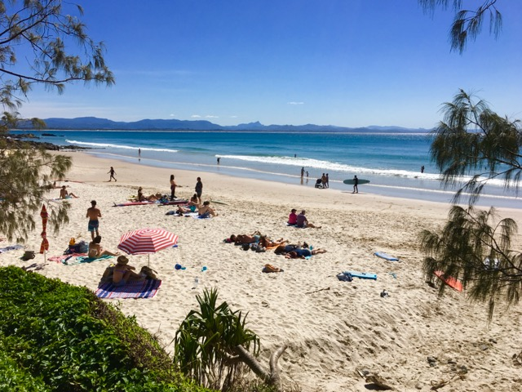
DAY 3 – LAMINGTON NATIONAL PARK (O’REILLY’S)
- Canungra Valley – Drive through the old timber-getting town and along the beautiful valley.
- Kamarun Lookout – Truly stunning 270 degree views over the gorgeous Sarabah Valley, over to Springbrook and the Scenic Rim.
- Morning tea at the alpaca farm of freshly made scones with tea or coffee over a beautiful valley.
- Get high in the rainforest at O’Reillys Rainforest Retreat’s famous treetops walk.
- Lunch at O’Reillys Café with views over the valley.
- Feed the brightly coloured native birds – crimson rosellas and king parrots.
- Interpretive rainforest walk to beautiful waterfalls. Short option and long option deep into the rainforest available.
- Off-roading (4WD) over remote mountains far away from other tourists on Duck Creek Road. Stop along the way for spectacular views of the surrounding mountains and farmlands and to see unique rainforest species.
- Look out for species of kangaroo and wallaby as we drive through the mountains.
- Accommodation Suggestion: O’Reilly’s Rainforest Retreat Villas
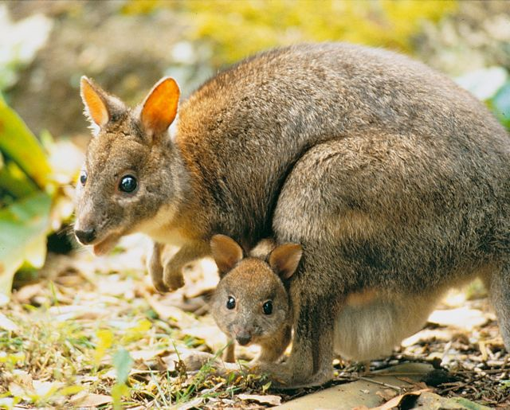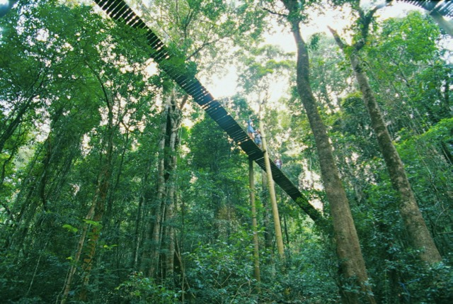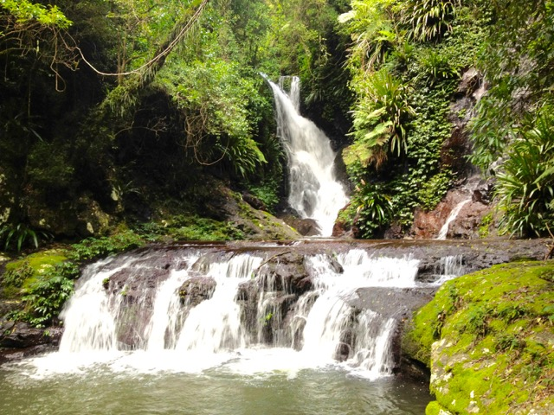

DAY 4 – SCENIC RIM
- Boonah - quaint rural township with superb views from the lookout to the western Scenic Rim mountain range and the town’s famous 18 ft high ‘Blumbergville’ clock made from farming equipment.
- Wander the Kooroomba lavender fields (May to September) with ancient volcanic mountains as a backdrop.
- Lunch at Kooroomba winery (Wed – Sun) with amazing views over the lavender fields (in season) and mountains.
- Option of sampling the impressive whites, reds & port from The Rim’s volcanic soils at the boutique winery.
- Drive around Lake Moogerah for a unique perspective of The Rim’s mountains.
- As we drive, learn about the region’s pioneering past, including Aboriginal history, European exploration and Coochin station – visited by royalty.
- We arrive at our accommodation today a little earlier than normal to enjoy the beauty, serenity and luxury of Australia’s highest non-alpine lodge, Spicers Peak Lodge.
- Accommodation Suggestion: Spicers Peak Lodge
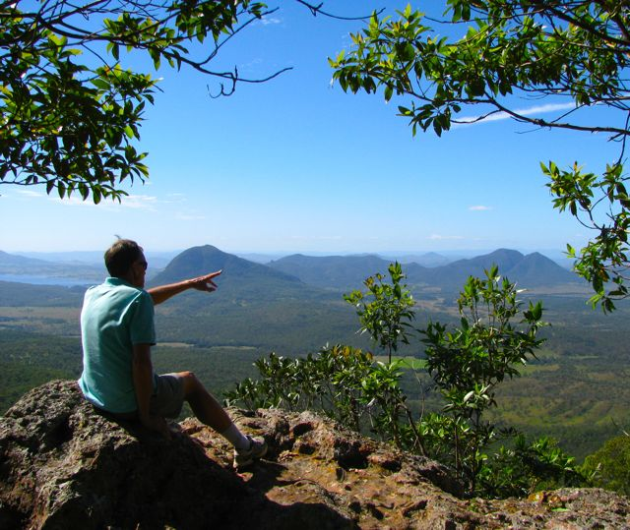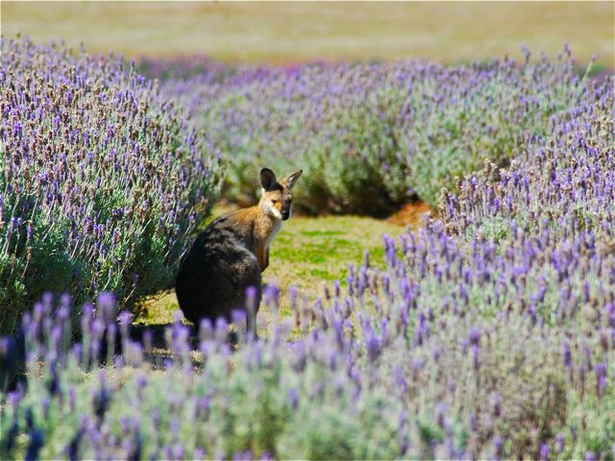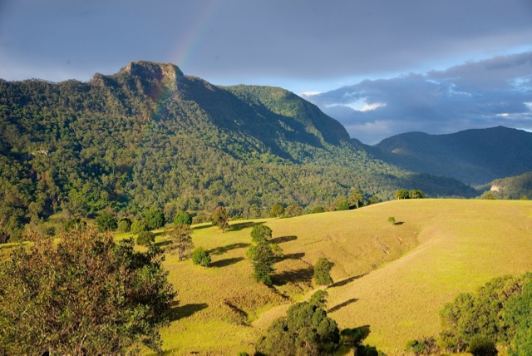

DAY 5 – QUEEN MARY FALLS & 14 RIVER CROSSINGS ROAD
- Drive through the scenic farmlands on the western side of the Great Divide.
- Queen Mary Falls and track – A short walk takes you through eucalypt forest to the top of the 40 metre high Queen Mary Falls. The active guests can take the full walk to the large rockpool at the base of the falls with rainforest species.
- Hand-feed brightly coloured native king parrots and rosellas.
- A brief walk takes you to a unique perspective looking down onto the top of Daggs Falls.
- Gourmet lunch with stunning mounatin views over Condamine Gorge to Mt Superbus.
- The "Moss Gardens" – Short walk with lichen covered trees and lookout into New South Wales.
- If time allows – detour via Green Hills Rd – “The most beautiful road in Australia” Steve Irwin.
- Accommodation Suggestion: Spicers Peak Lodge.

DAY 6 – SUNSHINE COAST HINTERLAND (VIA LAKE SOMERSET)
- Lush, sub-tropical rainforest walk high on the World Heritage Listed Main Range National Par (or Mary Cairncross Park later in day). Enjoy a guided eco-walk through lush, sub-tropical rainforest – an easy 45-minute stroll.
- Drive through the Scenic Rim and past Lakes Wivenhoe and Lake Somerset, stopping at great viewing points along the way.
- Relax with morning tea at a delightful country café.
- A superb lunch is matched only the amazing views over the unique Glasshouse Mountains. Learn the Aboriginal legend of how the mountains were formed as well as the geological descriptions.
- Overlooking the Glasshouse Mountains is Maleny Botanical Gardens – described by ‘The Garden Guru’ as “The most exquisite gardens I have ever seen in my 41 years in the garden business!”.
- One of Australia’s largest bird aviaries is 1000 m² and filled with 350 birds from Australia and the world. You may let the many stunningly coloured, endangered birds land on you.
- If time allows, stop by the Australian Wildlife Education Centre as you finish the walk.
- Option of either wandering through the charming mountain village of Montville, wine tasting, gourmet cheese tastings or arrive early at our accommodation to wander through the rainforest or look at the brightly colored birds at Narrows Escape.
- Accommodation Suggestion: Narrows Escape.
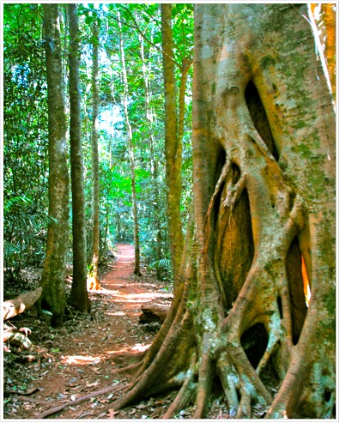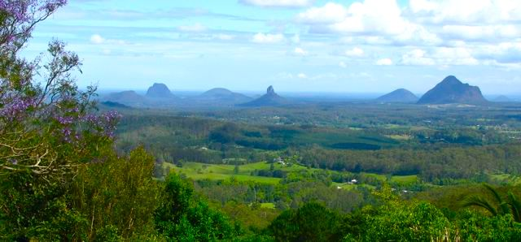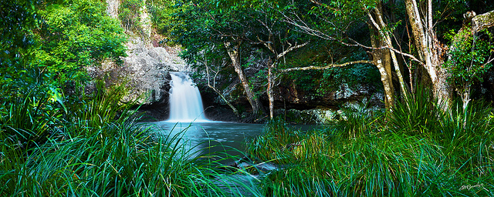

DAY 7 – NOOSA & SUNSHINE COAST BEACHES
- Beautiful Caloundra Headland walk from King’s Beach to Happy Valley with views to Bribie Island. Look out for possible manta rays, turtles, dolphins and whales in season.
- Beacon Lighthouse Reserve, Mooloolabah Beach and walk ‘into the water’ on a sandbar at Maroochydoore if tide is right.
- Drive along the Sunshine Coast’s gorgeous coastline, stopping at Coolum Beach.
- Option for the active guests to climb the short but very steep dome of Mt Coolum – for stunning 360 degree views 200 metres asl.
- Drive past the amazing waterfront homes and along pristine Noosa River with lovely views of the river, lake and forests.
- Guided eco-walk through the headlands of Noosa National Park stopping at remote bays and beaches (you may even see a koala!).
- Time in the afternoon for your choice of 1) extending headland walks, 2) relaxing at some of the most beautiful beaches in the world, or 3) shopping on Noosa’s famous Hastings Street with trendy cafes and ‘ultra-luxe’ shopping boutiques.
- Accommodation Suggestion: Narrows Escape

